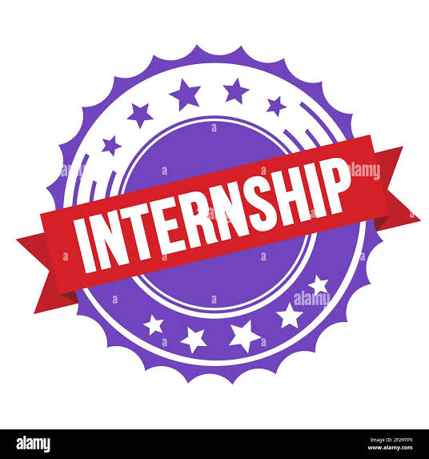

M TECH PRODUCTION AND MARKETING:
INTERN: HALEEMA SAJID KHAN
SUBMITTED TO: MOHAZIN ZAHID
DOMAIN: AI AND ML

REPORT OF DAY 4
Introduction
This report describes the work completed during the M-Tech Production & Marketing AI/ML Internship Program on 2nd July 2026. The main focus of the session was to improve Python programming knowledge by learning about data structures and conditional statements. Different coding activities were performed to build logical thinking and strengthen basic programming skills.
Objectives
- Learn the purpose and use of Python data structures.
- Understand how conditional statements are used to make decisions in programs.
- Develop logical thinking through hands-on coding practice.
- Build a stronger foundation in Python for future AI and Machine Learning projects.
Task Description
The session covered the concepts of Python data structures and conditional statements. Several beginner-friendly programming tasks were completed to apply these concepts in practical situations. These activities helped improve coding ability and increased confidence in writing Python programs.
Work Done
During the internship session, I explored different Python data structures and practiced using conditional statements to control the flow of programs. I completed multiple coding exercises to strengthen my understanding of these concepts and improve my programming skills. After finishing the practical tasks, I prepared a detailed report to document the day's learning and activities.
Challenges Faced
Although the topics were easy to understand, selecting the correct conditional statements for different programming problems required careful analysis and regular practice. Solving various coding exercises helped improve my logical thinking and problem-solving skills.
Key Learnings
This session gave me a better understanding of Python data structures and conditional statements. I learned how these concepts are combined to create well-structured and efficient programs. The practical exercises also increased my confidence in writing Python code without much guidance.
Conclusion
The activities completed during this session strengthened my understanding of Python through both theory and practical work. The coding exercises improved my logical reasoning and problem-solving abilities, providing a solid foundation for learning more advanced programming concepts during my internship.

